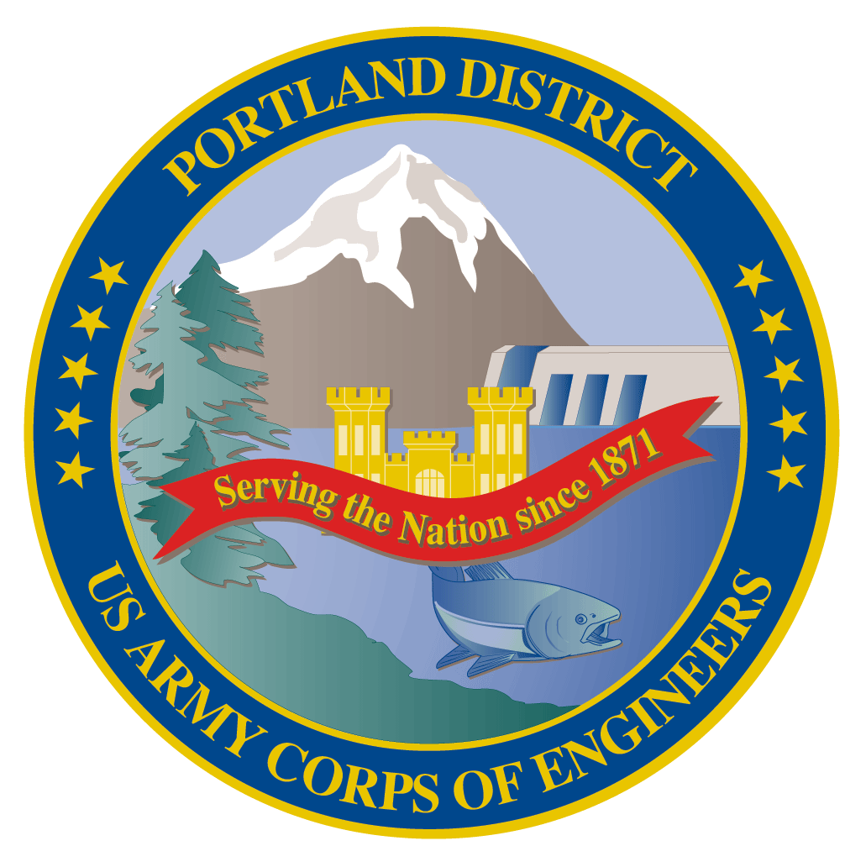Lower Columbia River Fish Facility Design Review Work Group (FFDRWG)

USACE, Portland District

# November 2021 Meeting Agenda

November 4, 2021 09:00-11:00

Join Meeting: https://usace1.webex.com/join/jacob.macdonald

Meeting Number: 1995 00 9820

*(*if using your phone for audio, log in through Webex and have the meeting call you)*

Join by phone (audio only, no Webex): (844) 800-2712 | Access Code: 1995 00 9820

## Introductions

FFDRWG members:

**BPA**

Scott Bettin

Kim Johnson

Siena Lopez-Johnston

Christine Petersen

Greg Smith

Leah Sullivan

Ben Hausmann

**NOAA**

Blane Bellerud

Gabriel Brooks

Trevor Conder

Kinsey Frick

Claire McGrath

Josie Thompson

Logan Negherbon

**USFWS**

Dave Swank

**States**

Erick Van Dyke (ODFW)

Charles Morrill (WDFW)

Jonathan Ebel (IDFG)

**CRITFC/Tribes**

Tom Lorz (CRITFC)

Blaine Parker (CRITFC)

Tom Skiles (CRITFC)

Laurie Porter (CRITFC)

Greg Silver (CRITFC)

Casey Baldwin (CTCR)

Michael Karnosh (CTGR)

Lawrence Schwabe (CTGR)

Torey Wakeland (CTGR)

Aaron Jackson (CTUIR)

Ralph Lampman (YN)

**NPCC**

Leslie Bach

Kris Homel

**FPC**

Erin Cooper

**PSMFC**

Alan Brower

Darren Chase

Roger Clark

Mark Leonard

Scott Livingston

Nicole Tancreto

Don Warf

**CENWD**

Doug Baus

Tim Dykstra

Dan Feil

Mike Langeslay

Cindy Studebaker

Lisa Wright

**CENWW**

Karl Anderson

Chris Peery

Marvin Shutters

Denise Griffith

**CENWP-OD**

Andrew Derugin

Rebecca Cates

Jeanette Wendler

Bob Cordie

Jeffrey Randall

Scott Fielding

Eric Grosvenor

Michael Lotspeich

Laura Rickets

Tammy Mackey

Darren Gallion

Nathan McClain

Robert Wertheimer

Karrie Gibbons

**CENWP-PM**

Jim Adams

Eric Bluhm

Ian Chane

Jeff Hicks

Steve Sipe

Bob Winters

Brad Eppard

David Griffith

Fenton Khan

Rachel Laird

Jake Macdonald

Rich Piaskowski

Jon Rerecich

Ida Royer

David Trachtenbarg

Jeremiah Woodard

Erin Kovalchuk

Michael Carl *welcome*

**CENWP-ENC**

Adam White

Brandt Bannister

Bridget Bell

Jonathon Brink-Roby

Shari Dunlop

Laurie Ebner

Curtis Lipski

Chris Motti

Steve Schlenker

Max Wilson-Fey

Mehdi Roshani

## Action items from previous meetings

* Derugin will distribute a collection of LPS design criteria/guidelines to the appropriate PDT’s and FFDRWG
* Grosvenor will present the backup AWS debris management alternatives at an upcoming FFDRWG
  + EDR shelved at 50% with no funding in FY 22. Grosvenor will walk through alternatives with FFDRWG at 60% (when the project resumes)
* BPA (Bettin) will present the TDA fish unit rehab report at an upcoming FFDRWG
  + Today, or next time? (Bettin)

## Topics for FFDRWG Discussion/Review/Coordination

* JDA adult lamprey passage improvements – Eric Bluhm (PM), Adam White (TL), Eric Grosvenor (FC)
  + Update on gravity feed water supply alternatives investigation (Grosvenor/White)
* BON2 adult lamprey passage improvements – Michael Carl (PM), Shari Dunlop (TL), Andrew Derugin (FC)
  + Site specific construction cost estimate is in! (Dunlop)
  + Overview of current (<30%) design weirs and antennas (Dunlop/Brower)
  + Chamfer or radius on orifice edges? (Dunlop/Brower)
  + PIT detectors for lamprey orifices? (Dunlop/Brower)
* BON1 adult lamprey passage improvements – Michael Carl (PM), Adam White (TL), Andrew Derugin (FC)
  + Lamprey orifices going in the serpentine section this Winter (Derugin)
  + FFDRWG site visit to the dewatered ladder in December-January? (Macdonald)
* Ladder cooling water - **\*\*potential future project\*\***
  + Continue discussion of the feasibility of a ladder temperature control project at John Day Dam, transition discussion to AFEP/SRWG or FPOM (Grosvenor/Macdonald/Conder)

## Written project updates

* JDA turbine rehab – Steve Sipe (PM), Curtis Lipski (TL), Jon Rerecich (FC)
* TDA AWS Debris Management– Erin Kovalchuk (PM), Mehdi Roshani (TL), Eric Grosvenor (FC)
* BON Second Powerhouse FGE – Jim Adams (PM), Bridget Bell (TL), Eric Grosvenor (FC)
* JDA adult lamprey passage improvements – Eric Bluhm (PM), Adam White (TL), Eric Grosvenor (FC)
* TDA adult lamprey passage improvements – Eric Bluhm (PM), Adam White (TL), Eric Grosvenor (FC)
* BON1 adult lamprey passage improvements – Michael Carl (PM), Adam White (TL), Andrew Derugin (FC)
* BON2 adult lamprey passage improvements – Michael Carl (PM), Shari Dunlop (TL), Andrew Derugin (FC)

Fish Facility Design Review Work Group (FFDRWG)

USACE, Portland District

Project Update

Date Prepared/Updated: 2021-04-01

# JDA Turbine Rehab

|  |  |
| --- | --- |
| Project Identifier: | P2 # |
| Project Manager (PM): | Steve Sipe (CENWP-PMF-P)  *Steven.C.Sipe@usace.army.mil* |
| Technical Lead (TL): | Curtis Lipski (CENWP-ENC-HD)  *Curtis.L.Lipski@usace.army.mil* |
| FFDRWG Coordination (FL): | Eric Grosvenor (CENWP-PME)  *Eric.Grosvenor@usace.army.mil* |

## Project Description

The purpose of this project is to address reliability concerns and maximize production of hydroelectric power at JDA, which includes electrical energy production and electrical grid ancillary services while at the same time, improving survival of fish passing through the turbines. Maximum production of hydroelectric power at JDA will be realized through increased reliability and increased efficiency. Reliability improvements will be realized through a combination of replacement and refurbishment of powertrain equipment to include, but not limited to, turbine runners, shafting, generators, isophase bus, breakers, switches, and transformers. Efficiency improvements will be realized through increased turbine efficiencies associated with new turbine runners and other modifications to the turbines.

The purpose of this project is also to increase survival of turbine passed fish. Increased survival of turbine passed fish will be realized through developing state-of-art hydroelectric turbines to obtain improved fish passage survival through the turbines. The design of the state-of-the-art turbines will be an iterative and collaborative process that focuses on fish-friendly design features and criteria. This iterative and collaborative design process will be similar to the ongoing Ice Harbor L&D turbine runner replacement design and upcoming McNary L&D turbine runner replacement in NWW. Phase 1A recommendations include replacing up to 14 units with combination fixed blade & adjustable blade to obtain improved fish passage survival through the turbines.

## Project Schedule

|  |  |  |
| --- | --- | --- |
| Phase 1 Short Term Schedule | Start | Finish |
| 30% DDR/P&S review | 3/12/2020 | 4/1/2020 |
| 60% DDR/P&S review | 8/28/2020 | 9/18/2020 |
| 90% DDR/P&S review | 9/21/2021 | 2/18/2022 |
| BCOES review | 1/24/2022 | 11/11/2022 |

|  |  |
| --- | --- |
| Overall Schedule Milestones | Date |
| Contract award | October 2024 |
| Collaborative design process Model testing | 2024-2029 |
| First unit installation | 2031-2033 |
| Unit installation complete | 2040-2045 |

## Current Status

* Final VE study report due Feb. 19, 2021
* The 1:25 scale physical observational turbine model rehab and relocation is complete. The model will be used to inform the development of the Phase 1 Plans and Specifications package, to document the hydraulic conditions that affect the biological performance of the existing JDA turbines, and to support the collaborative and iterative design process in Phase 2. ERDC baseline model validation testing with the existing runner has been scheduled for last week and this week. Baseline model data collection for Test Series 1 will be occurring until May 2021 at which time ERDC is scheduled to transition back to McNary. This task includes preparation of a data report documenting the runs performed, results, conclusions, and recommendations. Runner evaluation tests will need to carry over to Test Series 2 (not yet scoped), which is expected to occur in late 2021 or early 2022.
* Tailrace flow patterns have been validated in the 1:45 JDA general model and in a CFD model. Model runs will commence after further HAC modeling is complete and preliminary options for the turbine mix are established. The focus of the tailrace modeling will be to assess juvenile egress and conditions for adult approach to the fish ladder entrances.

## Topics for FFDRWG Review/Coordination

None currently.

Fish Facility Design Review Work Group (FFDRWG)

USACE, Portland District

Project Update

Date Prepared/Updated: 2021-10-28

# TDA Backup AWS Debris Management EDR

|  |  |
| --- | --- |
| Project Identifier: | P2 # |
| Project Manager (PM): | Erin Kovalchuk (CENWP-PMF)  *Erin.H.Kkovalchuk@usace.army.mil* |
| Technical Lead (TL): | Mehdi Roshani (CENWP-ENC)  *Mehdi.Roshani@usace.army.mil* |
| FFDRWG Coordination (FC): | Eric Grosvenor (CENWP-PME)  *Eric.Grosvenor@usace.army.mil* |

## Project Description

This project is to evaluate alternatives to remove debris from The Dalles Dam Auxiliary Water Supply (AWS) trash rack. Debris build-up on the rack currently causes high head differential across the rack. Fish Unit Rehab requires the AWS backup system to operate during the rehab to provide adequate flow for fish attraction. Fish Unit Rehab duration is one year per unit for a total of two years. Long term use of the backup AWS system will be part of the alternatives evaluation.

## Project Schedule

|  |  |  |
| --- | --- | --- |
| **Milestone** | **Start** | **End** |
| **Criteria and Constraint Report** | 4/19/2021 | 8/6/2021 |
| **Value Management** | 8/9/2021 | 8/20/2021 |
| **Alternative Evaluation Report** | 8/23/2021 | 12/10/2021 |
| **Draft Final Report** | 12/13/2021 | 4/1/2022 |
| **ATR** | 3/21/2022 | 4/1/2022 |
| **Final Report** | 4/4/2022 | 5/27/2022 |
| **Closeout** | 5/30/2022 | 6/3/2022 |

## Current Status

Value Management Study completed.

No Funding in FY 22

Engineering Design Report (EDR) shelved at 50%

## Topics for FFDRWG Review/Coordination

PDT will solicit FFDRWG participation at the 60% Engineering Design Report (EDR).

Fish Facility Design Review Work Group (FFDRWG)

USACE, Portland District

Project Update

Date Prepared/Updated: 2021-10-28

# BON Second Powerhouse FGE

|  |  |
| --- | --- |
| Project Identifier: | P2 # |
| Project Manager (PM): | Jim Adams (CENWP-PMF)  *James.R.Adams@usace.army.mil* |
| Technical Lead (TL): | Bridget Bell (CENWP-ENC)  *Bridget.M.Bell@usace.army.mil* |
| FFDRWG Coordination (FL): | Eric Grosvenor (CENWP-PME)  *Eric.Grosvenor@usace.army.mil* |

## Project Description

Steel plates were installed in all units in the A and B gatewells to restrict flow. During routine inspections, however, it became apparent that the anchoring system for the steel plates was inadequate. In effect, the nuts and anchoring bolts holding down the plates had come loose, posing the risk that the plates could detach and potentially take out a unit. All flow restriction plates were removed from the units. A concrete corbel will be installed in the same location as the flow control plates with the design goal to achieve similar gatewell hydraulic conditions as the flow control plates. This new concrete corbel has been designed to meet the flow criteria established and tested for the previous flow restrictor plates to meet the hydraulic and biological goals.

## Project Schedule

|  |  |  |  |  |
| --- | --- | --- | --- | --- |
| CLIN | Status | Description | Award/Exercise Date | Construction Execution Window |
| 1 | Mandatory | Mobilization/Demobilization | Awarded December 2020 | Complete |
| 2 | Mandatory | Unit 15 Construction | Awarded December 2020 | Complete |
| 3 | Optional | Second Mob/Demob and Unit 11 Construction | Awarded August 2021 | Dec 2022-Feb 2023 |
| 4 | Optional | 2 Additional Units | Awarded August 2021 | Extend through May 2023 |
| 5 | Optional | 2 Additional Units | Awarded August 2021 | Extend through August 2023 |
| 6 | Optional | 2 Additional Units (Unit 18 + 1 more Unit) | Awarded August 2021 | Extend through February 2024 |

## Current Status

* Construction in unit 15 is complete. The contractor did great work, and we had very few RFIs and only one modification.
* Optional construction CLINs were awarded August 2021. We will modify the dates of execution extending them out a year to allow us to test in the spring of 2022 prior to installing the remaining corbels.
* AE contract for hydraulic testing in Spring 2022 was awarded in September 2021. Hydraulic tests will be needed in the spring to meet the upper 1% test range of 18.0-18.5 kcfs.
* Original contract schedule said we would continue with units, 12, 13, 14, 16, and 17 and then end with either 11 or 18 the following IWW. However, the contractor thinks they can do both 11 and 18 in the 2022-2023 IWW and then finish with the remaining units throughout the spring/summer. The PDT is confident they can achieve that after how well unit 15 went. We will confirm their schedule after we get the modification in place.
* Rerecich owes Lorz a beer.

## Topics for FFDRWG Review/Coordination

None currently.

Fish Facility Design Review Work Group (FFDRWG)

USACE, Portland District

Project Update

Date Prepared/Updated: 2021-10-27

# JDA adult lamprey passage improvements

|  |  |
| --- | --- |
| Project Identifier: | P2 # 492402 |
| Project Manager (PM): | Eric Bluhm (CENWP-PM-FP)  *Eric.V.Bluhm@usace.army.mil* |
| Technical Lead (TL): | Adam White (CENWP-ENC)  *Adam.J.White@usace.army.mil* |
| FFDRWG Coordination (FC): | Eric Grosvenor (CENWP-PME)  *Eric.Grosvenor@usace.army.mil* |

## Project Description

### Modify NFL LPS to increase the capacity and reliability of the system

This is a fish safety/health issue, and the upgrade needs to happen. Current water supply is insufficient so tank cannot be installed without upgraded water supply. SeeJanuary 2020 CRS BA § 2.5, pg. 2-85***.***

1. gravity-fed water supply or alternative, more reliable pump configuration.
2. larger collection box

### SFL entrance improvements (rounded crest, slot cover/filler)

Caps may not be able to be added to South Ladder entrance weir due to FPP submergence criteria, so the weir may need to be modified more extensively to provide rounded weir crests and guide slot covers.

### SFL count station collection and counting structure (trap) improvements

*Increase capacity and efficiency of system with a larger opening into box; larger box, modified guide, and removal of gate and counting-related structure.*

## Project Schedule

Design: FY 2021 – FY 2022

30% DDR – July 2021

60% DDR – November 2021

90% DDR – April 2022

BCOES – May 2022

Construction: December 2022 - March 2023

Evaluation/Closeout: FY 2023

## Current Status

60% DDR is underway. PDT is evaluating options for gravity feed water from behind existing picketed leads near the count station via an existing diffuser drain line. A surplus holding tank at JDA will be modified and relocated to serve as the larger collection box.

## Topics for FFDRWG Review/Coordination

None currently. PDT will ask for FFDRWG review of design alternatives at 60% or 90% DDR stage.

Fish Facility Design Review Work Group (FFDRWG)

USACE, Portland District

Project Update

Date Prepared/Updated: 2021-10-27

# TDA adult lamprey passage improvements

|  |  |
| --- | --- |
| Project Identifier: | P2 # 492403 |
| Project Manager (PM): | Eric Bluhm (CENWP-PM-FP)  *Eric.V.Bluhm@usace.army.mil* |
| Technical Lead (TL): | Adam White (CENWP-ENC)  *Adam.J.White@usace.army.mil* |
| FFDRWG Coordination (FC): | Eric Grosvenor (CENWP-PME)  *Eric.Grosvenor@usace.army.mil* |

## Project Description

### Lamprey collection system (LPS) at the east fish ladder junction pool

Provide a ramp (or multiple) for lamprey to swim out of the junction pool and into a collection box located below the upper segment of the fish ladder for upstream transport. SeeJanuary 2020 CRS BA § 2.5, pg. 2-85***.***

### Modify elevated orifices in EFL exit weirs 154-157

Provide better lamprey passage options through the 4 control weirs at the upstream end of the east fish ladder.

### Bulkhead slot covers

Design and install bulkhead slot covers at all four fishway entrances.

## Project Schedule

Design: FY 2021 – FY 2022

30% DDR – August 2021

60% DDR – December 2021

90% DDR – April 2022

BCOES – June 2022

Construction: December 2022 - March 2023

Evaluation/Closeout: FY 2023

## Current Status

60% DDR is underway. Preferred LPS design includes water supplied from an existing 6” pipe through the dam that provides irrigation water from the forebay to a park in the tailrace, a large collection box on the deck near the junction pool, and 1-3 climbing ramps reaching down to the fishway floor.

## Topics for FFDRWG Review/Coordination

None currently. PDT will ask for FFDRWG review of design alternatives at 60% or 90% DDR stage.

Fish Facility Design Review Work Group (FFDRWG)

USACE, Portland District

Project Update

Date Prepared/Updated: 2021-10-27

# BON1 adult lamprey passage improvements

|  |  |
| --- | --- |
| Project Identifier: | P2 # 492400 |
| Project Manager (PM): | Bob Winters (CENWP-PM-FP)  *Robert.Winters@usace.army.mil* |
| Technical Lead (TL): | Adam White (CENWP-ENC)  *Adam.J.White@usace.army.mil* |
| FFDRWG Coordination (FC): | Jacob Macdonald (CENWP-PME)  *Jacob.Macdonald@usace.army.mil* |

## Project Description

The project scope is divided into three parts:

### Entrance Modifications

Modify the B-branch fish ladder entrance to improve lamprey passage. This includes a variable-width entrance weir with rounded edges, guide slot fillers or covers to aid lamprey passage along the walls, and bollards on the channel floor for hydraulic refuge.

### Lamprey Collection

Provide an alternate route for lamprey entering the B-branch of the Bradford Island fish ladder. Fish would climb up a flume structure to a holding tank on the deck of the dam and be transported upstream by Tribal fisheries personnel. This will be designed so that in the future we could extend the system to provide volitional passage to the Bonneville forebay.

### Serpentine Section Extensive Minor Mods

Upgrade the serpentine section of the Bradford Island fish ladder to improve lamprey passage by rounding corners, providing refuge boxes, and lamprey orifices.

## Project Schedule

Design: FY 2021 – FY 2022

30% DDR – July 2021

60% DDR – October 2021

90% DDR – January 2022

BCOES – March 2022

Construction: December 2022 - March 2023

Evaluation/Closeout: FY 2023

## Current Status

60% DDR is underway. PDT is investigating alternatives for collection box location and gravity-fed water supply.

## Topics for FFDRWG Review/Coordination

None currently. PDT will ask for FFDRWG review of design alternatives at 60% or 90% DDR stage.

Fish Facility Design Review Work Group (FFDRWG)

USACE, Portland District

Project Update

Date Prepared/Updated: 2021-08-31

# BON2 adult lamprey passage improvements

|  |  |
| --- | --- |
| Project Identifier: | P2 # 492401 |
| Project Manager (PM): | Bob Winters (CENWP-PM-FP)  *Robert.Winters@usace.army.mil* |
| Technical Lead (TL): | Shari Dunlop (CENWP-ENC)  *Shari.L.Dunlop@usace.army.mil* |
| FFDRWG Coordination (FC): | Jacob Macdonald (CENWP-PME)  *Jacob.Macdonald@usace.army.mil* |

## Project Description

Full redesign of control section (DDR, P&S, Construction).

2020 CRS BA Chapter 2: Proposed Action (pg.2-85): “This measure would modify the serpentine-style flow control sections of Bonneville Dam’s Washington Shore and Bradford Island fish ladders, converting them to Ice Harbor-style vertical slot with submerged orifices configurations. This would improve passage conditions for adult lamprey and likely reduce stress and delay for adult salmon, steelhead, and bull trout. All full-duplex passive integrated transponder (PIT) arrays currently located in the control sections of these ladders would be replaced in kind or improved to maintain or enhance current levels of detection of PIT-tagged anadromous fish.

## Project Schedule

Design: FY2021-FY2024

Construction: Winter 2024/2025

Evaluation/Follow-on: FY2025-FY2026

Closeout: FY 2027

Preliminary Milestones:

* Project Kick-Off: ~ August 2021 (FY21 Q4)
* 30% DDR: ~ December 2021 (FY22 Q1) **\*FFDRWG review ~Jan 2022**
* 60% DDR: ~ April 2022 (FY22 Q3) **\*FFDRWG review ~May 2022**
* 90% DDR: ~ July 2022 (FY22 Q4) **\*FFDRWG review ~Aug 2022**
* Draft-Final: ~ September 2022 (FY23 Q1) **\*FFDRWG review ~Oct 2022**
* [Start P&S after 90% DDR DQC is complete, ~August 2022]

## Current Status

Ongoing preliminary hydraulic work leading to a site-specific cost estimate ~October 2021.

## Topics for FFDRWG Review/Coordination

None currently. PDT will ask for FFDRWG review of design alternatives at 30% DDR stage.

